**Railway Station Data Management System**

*Project Synopsis Submitted*

*to*

**MANIPAL ACADEMY OF HIGHER EDUCATION**

*For Partial Fulfillment of the Requirement for the Award of the Degree of*

**Bachelor of Technology**

*in*

**Computer and Communication Engineering**

*by*

|  |  |
| --- | --- |
| Nandini Anand | Srinithya Halaharvi |
| 210953318 | 210953302 |

*Under the guidance of*

|  |  |
| --- | --- |
| **Mr. Akshay K C** | **Dr. Diana Olivia** |
| (Assistant Professor - Senior Scale  Department of Information & Communication Technology  Manipal Institute of Technology  Manipal, Karnataka, India) | (Assistant Professor - Selection Grade  Department of Information & Communication Technology  Manipal Institute of Technology  Manipal, Karnataka, India) |



**May 2023**

**ABSTRACT**

The Railway Station Management System is designed to manage the various activities of a railway station. It is used to automate and streamline the processes involved in the functioning of a railway station, including accessing train schedules, passenger information, and other related activities.

The system provides tools for station managers and other staff to manage and track train schedules, platform-ticket sales, passenger information, information about vendors and employee details.

Overall, this railway station management system database project will help improve the efficiency and accuracy of railway station operations, making the travel experience better for passengers and enabling railway station staff to manage operations more effectively.

Through this project, an attempt has been made to adhere to the Government of India’s Sustainable Development Goal- Industry, Innovation and Infrastructure

Here is a possible classification of the railway station management system in the ACM taxonomy:

Information systems: The railway station management system is an information system that processes data to provide useful information for decision-making.

Database management: The railway station management system relies on a database management system to store and manage vast amounts of data generated by various operations at the railway station.

Human-computer interaction: The railway station management system has a user interface that enables railway station staff to interact with the system and perform various tasks.

Software engineering: The development of the railway station management system involves various software engineering processes, such as requirements gathering, design, implementation, testing, and maintenance.

Operations research: The railway station management system may use operations research techniques to optimize various processes, such as train scheduling and cargo handling, to improve efficiency and reduce costs.

Data analytics: The railway station management system may use data analytics techniques to generate reports and analytics to help railway station management make informed decisions based on real-time data.

**Table of Contents**

|  |  |  |
| --- | --- | --- |
| **S No.** | **Title** | **Page No.** |
| **1.** | **List of Tables** | **5** |
| **2** | **Abbreviations** | **6** |
| **3.** | **Introduction** | **7** |
| **4.** | **Background** | **8** |
| **5.** | **Objectives/Problem Statement** | **9** |
| **6.** | **Data design** | **10** |
| **7.** | **Methodology** | **11** |
| **8.** | **Results** | **12** |
| **9.** | **Conclusion and Future Work** | **13** |
| **10.** | **References** | **14** |

**List of Tables**

1. **Train** (train_no int, t_name varchar, origin varchar, destination varchar )
2. **Station** (st_id int, s_name varchar)
3. **Stops_at** (train_no int, st_id int, arr_h int, arr_min int, dep_h int, dep_min int)
4. **PNR** (pnr_no int, train_no int, no_of_pass int, total_amt , p_source varchar, p_dest varchar)
5. **Passenger** (p_name varchar, pnr_no int, coach varchar, seat int, age int, gender varchar)
6. **Platform_ticket** (st_id int, serial_id int, qty int, fare int)
7. **Vendor** (v_id int, st_id int, name varchar, contact_no int)
8. **Shop** (shop_id int, st_id int, v_id int, platform_no int )
9. **Employee** (E_id varchar,E_name varchar, address varchar, gender varchar, salary int, b_date date, dep_id int, st_id int, e_password varchar)

1. **Departmen**t(dep_id int, d_name varchar)

Abbreviations

1. St_id :- station identification number
2. Train_no :- train number
3. Arr_h :- arrival hour
4. Arr_min :- arrival minute
5. Dep_h :- departure hour
6. Dep_min :- departure minute
7. Pnr_no :- passenger name record number
8. No_of_pass :- number of passenger
9. Total_amt :- total amount
10. Qty :- quantity
11. V_id :- vendor identification number
12. E_id :- employee identification number
13. E_name: employee name
14. B_date :- date of birth
15. Dep_id :- department identification number
16. D_name :- department name

**Chapter 1**

INTRODUCTION

Railway station management system database project is designed to manage various aspects of railway stations, including train schedules, passenger information, vendor information and employee information. The primary goal of this project is to streamline and automate various manual processes in the railway station, enabling more efficient and accurate management of railway operations.

The database for this system will store information about trains, passengers, tickets booked, and various other operational data. The system will also include a user interface that allows railway station staff to manage the database and perform various tasks related to train and passenger management.

Some of the key features of this railway station management system database project include:

* Train schedule management: The system will manage train schedules and allow railway station staff to make updates to the schedule when necessary.
* Passenger information management: The system will maintain records of passengers' personal information, such as their name and travel details.
* Train and passenger tracking: The system will enable railway station staff to track the progress of trains and monitor passenger movement within the station.

Overall, this railway station management system database project will help improve the efficiency and accuracy of railway station operations, making the travel experience better for passengers and enabling railway station staff to manage operations more effectively.

**Chapter 2**

Background

The railway system is one of the most significant transportation modes worldwide, and railway stations are the main hubs where passengers and cargo are received, processed, and dispatched. Managing a railway station can be a challenging task, with numerous processes involved, including train scheduling, ticket booking, passenger and cargo handling, and more.

In the past, these tasks were performed manually, with railway station staff relying on paper-based records to manage various operations. However, with the advent of technology, railway stations have started to automate their processes using software systems that help improve the efficiency and accuracy of their operations.

The railway station management system database project is one such initiative aimed at automating the management of railway stations. It aims to provide a robust and reliable software system that can handle various aspects of railway station management, such as train scheduling, passenger information, vendor movements and employee details.

The project aims to leverage database management systems to store and manage vast amounts of data generated by various operations at the railway station. The benefits of such a system are manifold. It can improve the efficiency and accuracy of railway station operations, reduce the workload of railway station staff, enhance the passenger experience, and enable railway station management to make informed decisions.

Overall, the railway station management system database project is an essential initiative aimed at modernizing railway station operations and making them more efficient and effective.

**Chapter 3**

Objectives / Problem Statement

The primary objective of the railway station management system is to provide a software system that can automate various manual processes involved in managing a railway station. The system aims to streamline railway station operations, improve the efficiency of various tasks, and enhance the overall passenger experience.

This database system has been designed for three railway stations, namely Udupi, Mangalore and Madgaon ;

The specific objectives of the railway station management system include:

* Display the train number, station identification number, arrival time (hour) and arrival time (minute) of trains that have already arrived according to the time and station identification number provided by the user.
* Display the train number, station identification number, arrival time (hour) and arrival time (minute) of trains that are yet to come according to the time and station identification number provided by the user.
* Display the train number, station identification number, departure time (hour) and departure time (minute) of trains that are yet to depart according to the time and station identification number provided by the user.
* Display the name, pnr number, age, gender and train number of incoming passengers who have arrived at a railway station according to the time and station name entered by the user.
* Display the name, pnr number, age, gender and train number of incoming passengers who are yet to arrive at a railway station according to the time and station name entered by the user.
* Display the name, pnr number, age, gender and train number of outgoing passengers who have left a railway station according to the time and station name entered by the user.
* Display the name, pnr number, age, gender and train number of outgoing passengers who are yet to leave from a railway station according to the time and station name entered by the user.
* A trigger is displayed every time a tuple is added to the passenger table
* When a train is added to stops_at table, a message displaying all the information of the train will be prompted
* Adding a temporary value to passenger table when a new PNR tuple is created.
* Number of passengers with source equal to a particular station name
* Number of passengers with destination equal to a particular station name.

**Chapter 4**

Design

4.1 ER Diagram

An Entity Relationship (ER) Diagram is a type of flowchart that illustrates how “entities” such as people, objects or concepts relate to each other within a system. ER Diagrams are most often used to design or debug relational databases in the fields of software engineering, business information systems, education and research. Also known as ERDs or ER Models, they use a defined set of symbols such as rectangles, diamonds, ovals and connecting lines to depict the interconnectedness of entities, relationships and their attributes. They mirror grammatical structure, with entities as nouns and relationships as verbs.

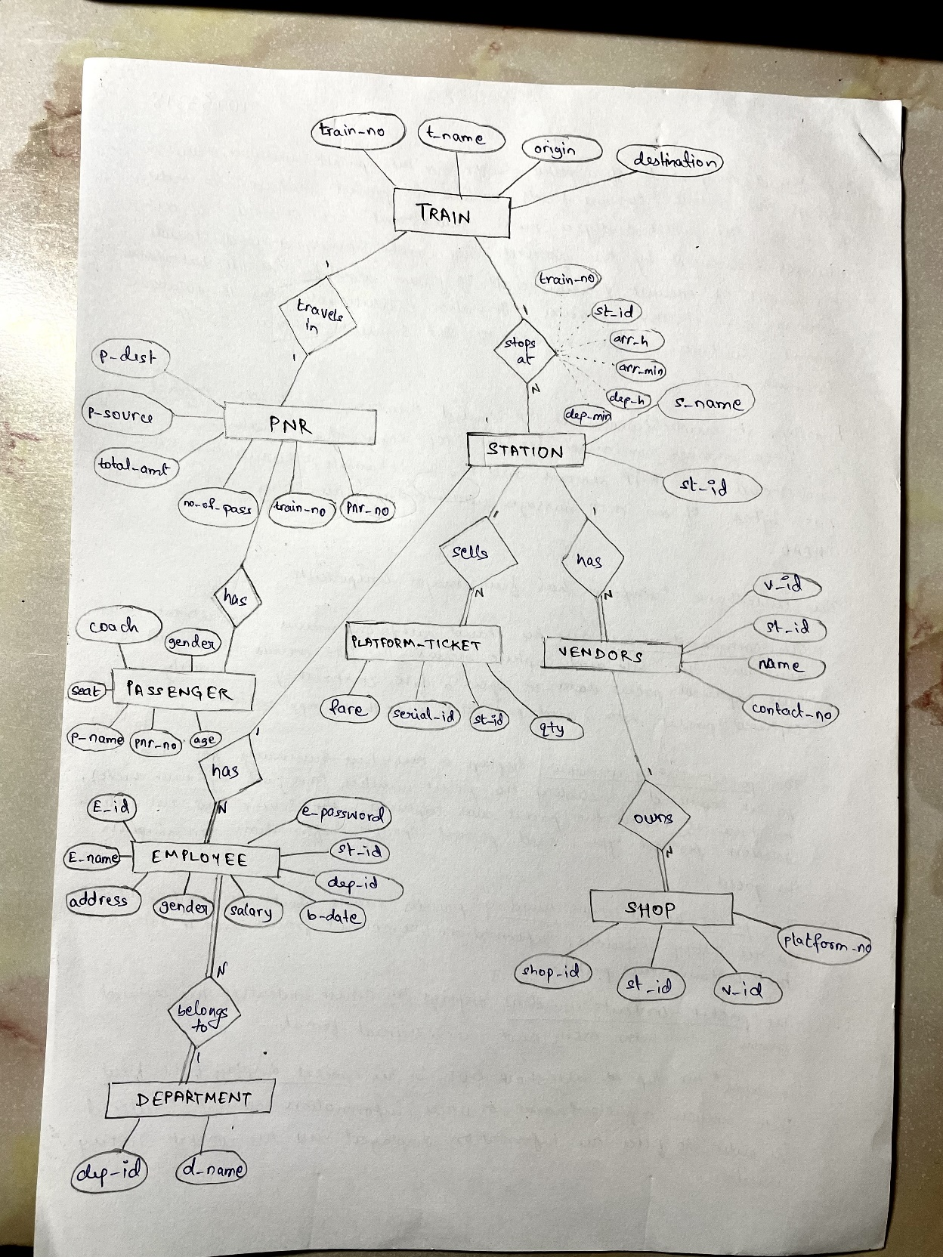

Fig. 4.1 ER Diagram of Railway Station Management Database

**Chapter 5**

Methodology

The methodology for making this project is discussed in the following points:-

Requirements gathering: The first step is to gather the requirements for the railway station management system. This involves identifying the operators, their needs and expectations, and the functional and non-functional requirements of the system.

System analysis and design: Once the requirements are gathered, the next step is to analyze the requirements and design the system. This involves identifying the components of the system, defining the system architecture, designing the database schema, and creating a high-level system design.

Database design and implementation: With the system design in place, the next step is to design and implement the database. This involves identifying the entities, attributes, and relationships, and designing the database schema. Then, the database is implemented using a suitable database management system (DBMS).

System implementation: With the database in place, the next step is to implement the system. This involves developing the software, testing the system, and integrating the database with the software.

System maintenance and support: After the system is deployed, it requires ongoing maintenance and support. This involves monitoring the system, fixing bugs, providing user support, and updating the system as necessary.

It is important to follow a structured methodology to ensure that the railway station management system database project is completed on time, within budget, and to the satisfaction of all stakeholders. The methodology should be flexible enough to accommodate changes and feedback throughout the project lifecycle.

**Chapter 6**

Results

The results of the railway station management system database project can be evaluated in terms of the system's performance, usability, and impact on railway station operations. Here are some possible results that can be expected from the project:

1. Improved data management: The system will enable efficient and effective management of vast amounts of data generated by various operations at the railway station, such as passenger and cargo handling, train scheduling, and ticketing.
2. Enhanced decision-making: The system will provide useful information for decision-making, enabling railway station staff to make informed decisions based on real-time data and analytics.
3. Increased efficiency: The system will streamline operations at the railway station, reducing delays and increasing the overall efficiency of railway station operations.
4. Improved customer experience: The system will improve the overall customer experience for passengers by reducing wait times, providing accurate information, and facilitating smooth and hassle-free travel.
5. Cost savings: The system will enable cost savings through improved efficiency, reduced delays, and better resource management.

Overall, the railway station management system database project has the potential to significantly improve the efficiency and effectiveness of railway station operations, leading to better customer experiences, increased revenue, and cost savings. The results of the project can be measured and evaluated using appropriate performance metrics and user feedback to continuously improve the system's functionality and performance.

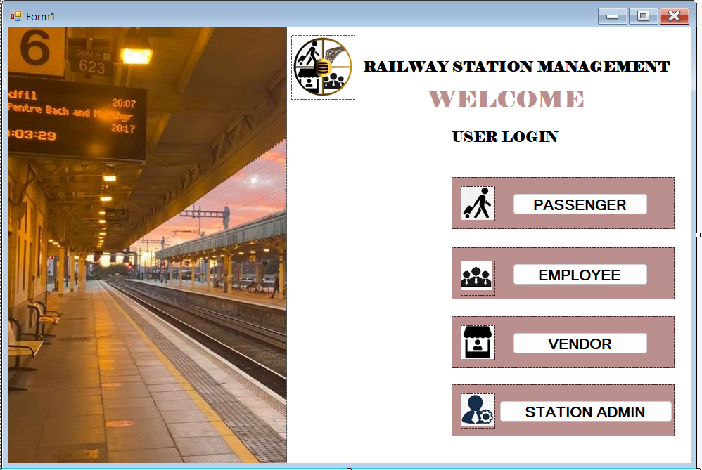

Fig 6.1 Login Page

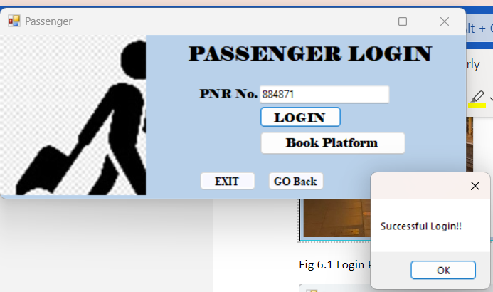

Fig 6.2 Passenger Login

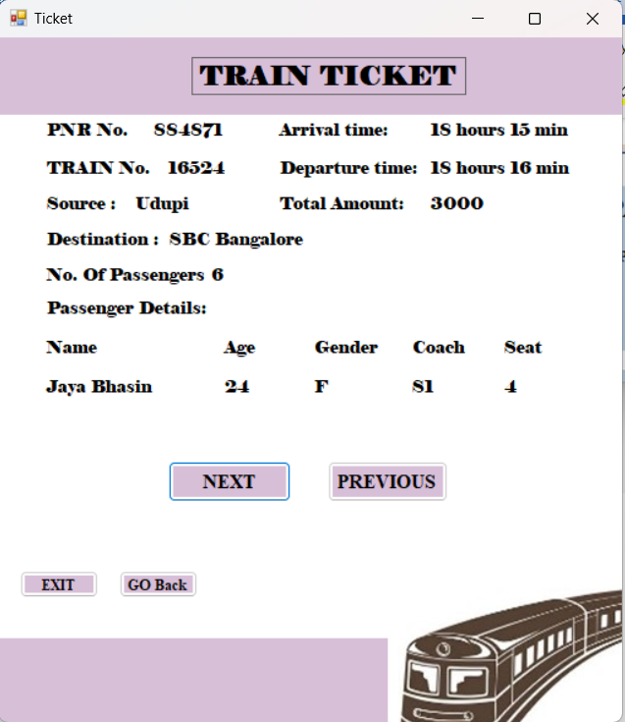

Fig 6.3 Passenger Details/Ticket (on click of next/previous button, the following/previous passenger’s details get displayed)

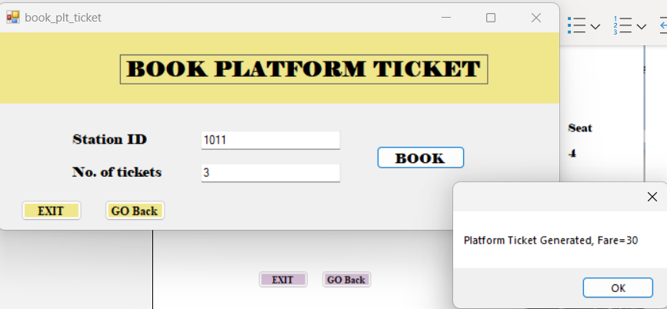

Fig 6.4 Platform Ticket Booking (the increment in total number of platform tickets gets reflected under employee module)

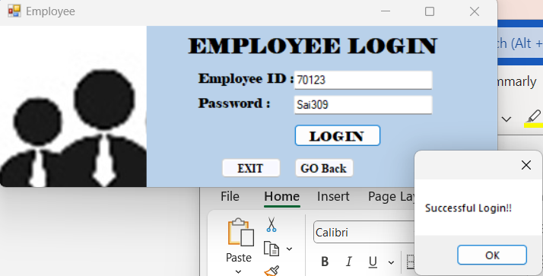

Fig 6.5 Employee Login

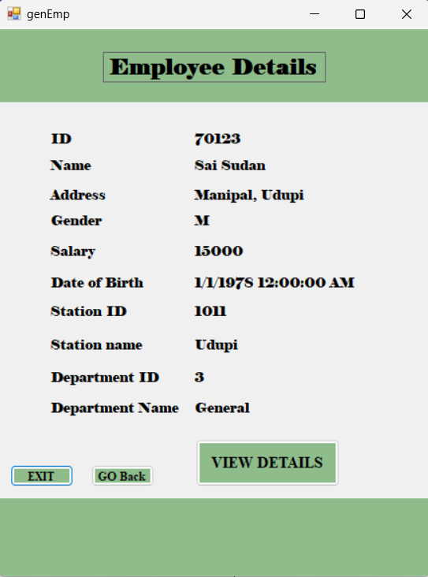

Fig 6.6 Employee Details

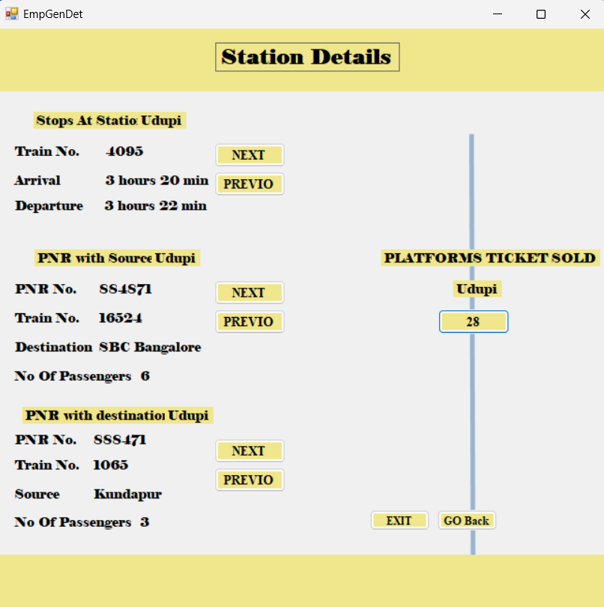

Fig 6.7 Information accessible to general employee (on click of next/previous button, the following/previous PNR &Train details get displayed)

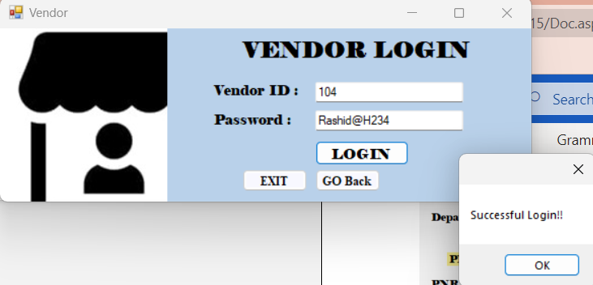

Fig 6.8 Vendor Login

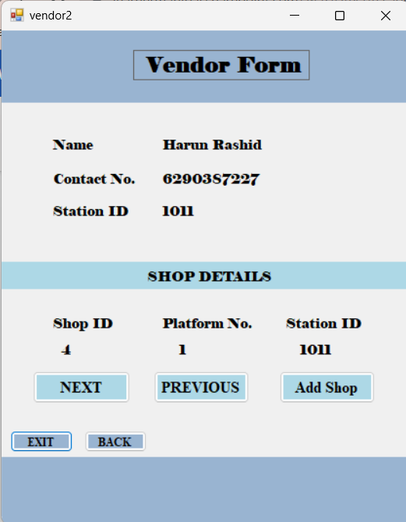

Fig 6.9 Information accessible to vendor (on click of next/previous button, the following/previous shop details owned by the vendor get displayed)

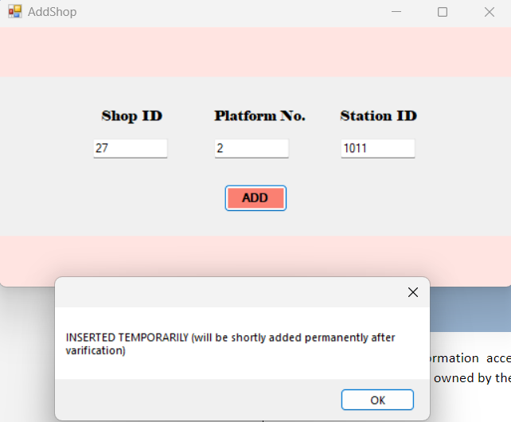

Fig 6.10 Vendor option to add shop

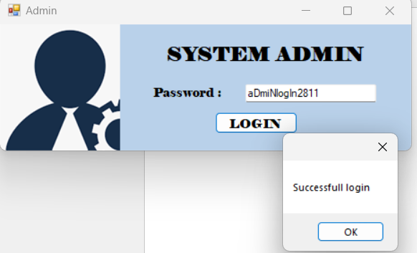

Fig 6.11 System Admin Login

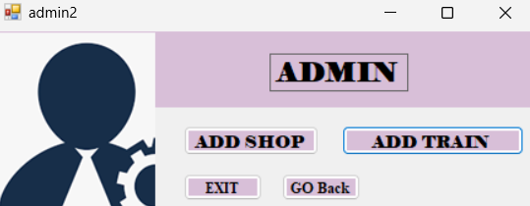

Fig 6.12 Function accessible to ADMIN

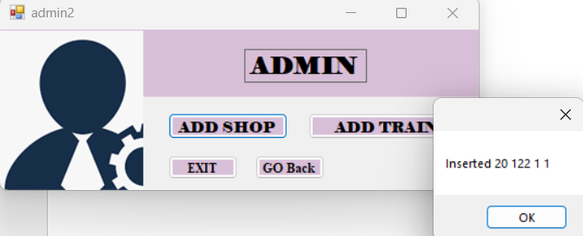

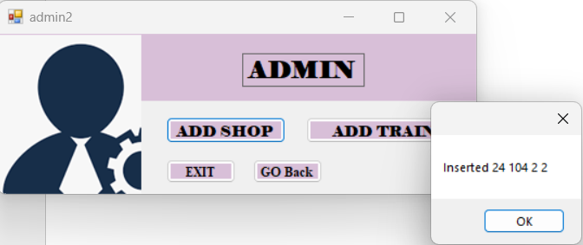

Fig 6.13 New shops applied by the vendor are added only after ADMIN’s approval

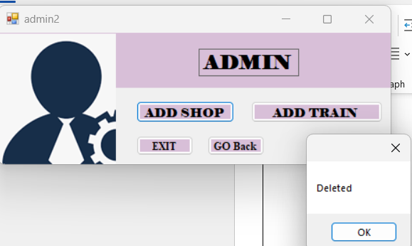

Fig 6.14 Once a new shop gets approved by the admin, it gets deleted from the temporary table (to avoid redundancy)

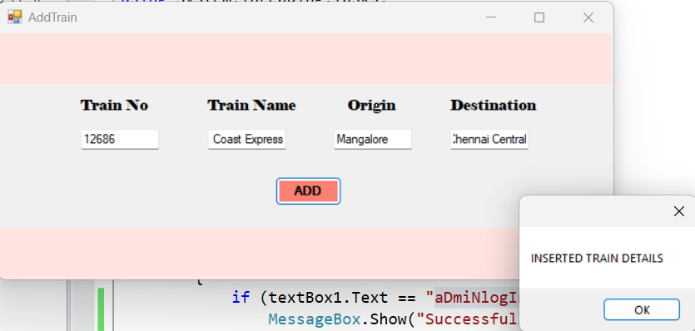

Fig 6.15 System Admin can add trains

**Conclusion and Future Work**

In conclusion, the railway station management system database project is an important initiative to improve the efficiency and effectiveness of railway station operations. The project involves designing and implementing a database that can store and manage vast amounts of data generated by various operations at the railway station, and developing software that can process the data to provide useful information for decision-making.

The methodology described earlier provides a general framework for completing the project successfully. However, there are several areas that could be considered for future work to enhance the system's capabilities and improve its functionality. Here are some potential areas for future work:

* Integration with other systems: The railway station management system database could be integrated with other systems, such as ticketing systems, train scheduling systems, and cargo tracking systems, to provide a more comprehensive view of railway station operations.
* Real-time analytics: The system could be enhanced to provide real-time analytics capabilities, allowing railway station staff to make informed decisions based on up-to-date data.
* Mobile applications: Mobile applications could be developed to allow railway station staff to access the system on the go, making it easier to manage operations from anywhere within the station.
* Predictive analytics: The system could be enhanced to provide predictive analytics capabilities, allowing railway station staff to anticipate potential issues and take preventive measures.
* Security and privacy: The system could be strengthened with enhanced security and privacy measures to protect sensitive data from unauthorized access and misuse.

Overall, the railway station management system database project has the potential to revolutionize railway station operations and enhance the overall experience for passengers and staff. With ongoing development and improvement, the system can continue to evolve to meet the changing needs of the railway industry and improve the efficiency and effectiveness of railway station operations.

**References**

Here are some references that were useful for the railway station management system database project:

"Railway station management system" by Prathibha and Manjula, International Journal of Scientific Research in Computer Science, Engineering and Information Technology (IJSRCSEIT), 2017.

"A Comprehensive Railway Station Management System" by Suhas Yellapragada, International Journal of Advanced Research in Computer Science and Software Engineering (IJARCSSE), 2017.

These references provide insights into various aspects of railway station management system database projects, including system design, implementation, performance evaluation, and user experience.